Alexander Baldree
07/22/26
Module 10.2 Assignment
CSD430

As I continued my journey of learning JavaServer Pages, also known as JSP, I started to notice how quickly a small web application could grow into a much larger project. At first, I only had a small amount of HTML and Java-based information placed throughout the JSP page. As I continued creating more pages, I then noticed that I was writing the same sections of code repeatedly. I would create the same navigation menu, warning message, database table, or page heading on several different pages. I realized that making changes to all these repeated sections could become difficult and take more time than needed. This is when custom tags became useful because they allowed me to take the JSP content I used throughout the project, place it into one reusable tag, and then proceed to use that tag on any page where it was needed.
Oracle describes custom tags as “user-defined JSP language elements that encapsulate recurring tasks” (Oracle, n.d.). This means that a developer can create their own JSP tag that performs a certain task. A custom tag looks similar to a normal HTML tag, but the developer creates and controls what the tag does. I could create a custom tag called <movie:card> that displays the title, genre, release year, and rating of a movie. I would then proceed to place the values inside the attributes of the tag instead of rebuilding the entire movie display every time I wanted it on another page.
As I started looking further into custom tags, one of the first advantages I noticed was code reuse. Oracle explains that “custom tags increase productivity because they can be reused in more than one application” (Oracle, n.d.). When I am creating a larger JSP project, repeating the same code throughout the application can make the project more difficult to update. If the same warning message appears on ten different JSP pages and I later want to change the design, I would normally have to proceed through all ten pages and make the same change. This could lead to mistakes because I may forget to change one page or accidentally use a different CSS class. When I use a custom tag, I only have to change the tag one time, and every JSP page using it will then receive the updated design.
Another advantage of custom tags is that they can make a JSP page easier to read. As I worked through different JSP database assignments, some of my pages started to contain HTML forms, input fields, database values, table elements, and JSP code inside the same file. As more code was added, it became harder to look through the page and immediately understand what each section was doing. A custom tag can remove some of the repeated presentation code from the page. Instead of looking through twenty lines of HTML to find a success message, I could see a single line such as <site:alert message="Record updated successfully"/>.
The Jakarta Server Pages documentation explains that “custom actions can be used by JSP authors and authoring tools to simplify writing JSP pages” (Eclipse Foundation, n.d.). I agree with this statement because a clearly named custom tag shows me what it is supposed to do without requiring me to read every line behind it. When I see a tag called <site:alert>, I already know that it is displaying an alert. When I see a tag called <movie:movieCard>, I know that the tag is displaying movie information.
Consistency is another reason I would consider using custom tags. As I continued creating JSP pages, I could accidentally use a different heading size, CSS class, table format, or spacing on one page. A custom tag gives the application one shared version of that section. This would be helpful for navigation menus, page headings, formatted dates, error messages, success messages, database record displays, and repeated form controls. It can also help another developer who works on the same project because they can use the existing tag instead of trying to rebuild the same section on their own.
Even though custom tags have several advantages, there are also disadvantages that I would need to consider. One disadvantage is the extra setup required to create them. If I only need to display a message one time, creating a separate custom tag file may take more work than placing the HTML directly into the JSP page. I would have to create the correct folder, create the tag file, define its attributes, import the tag library, and then test the tag. For a small section that will never be reused, this extra setup may not be worth the time.
Another disadvantage is that custom tags can make errors more difficult to find. If the output on the page is incorrect, the problem may not be directly inside the JSP page. I may have to check the custom tag file, the Java tag-handler class, the Tag Library Descriptor, the attributes being passed into the tag, or the folder where the tag is located. As the tag becomes more advanced, there are more places where a mistake could occur. This could become confusing if the tag does not have a clear name or proper documentation explaining how it should be used.
I also avoid placing too many application logic inside a custom tag. I would not want to create a tag called <movie:deleteRecord> that connects directly to the database and deletes a movie without clearly showing what is happening. The tag may appear to be a simple presentation element even though it is completing an important database operation. I believe database connections, record updates, deletions, and other major business operations should normally remain inside servlets, repositories, services, or other Java classes. I would use custom tags mainly for repeated presentation tasks instead of using them to hide major application processing.
As I reviewed the requirements for correctly developing a custom tag, I found that there are two common methods. The first and simpler method is creating a tag file. Oracle states that “a tag file is a source file that contains a fragment of JSP code that is reusable as a custom tag” (Oracle, n.d.). A tag file normally uses the .tag extension and allows the developer to create the tag using JSP-style syntax.
To create a tag file correctly, I would first proceed to create a folder named tags inside the project’s WEB-INF folder. The completed folder location would be /WEB-INF/tags/. I would then create a file such as alert.tag inside that folder. The tag file can declare attributes, use Expression Language, and produce the HTML that will be sent back to the JSP page. The attributes can also be marked as required so the developer must provide a value when using the tag.
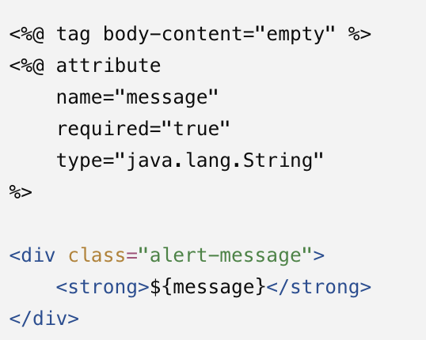
After creating the tag file, I would then proceed to import the tag directory into the JSP page. This is completed with the JSP taglib directive. The directive includes a prefix and the directory where the tags are stored. If I use site as the prefix and the file is named alert.tag, I can call the tag by writing <site:alert>. The .tag extension is not included when calling it from the JSP page.
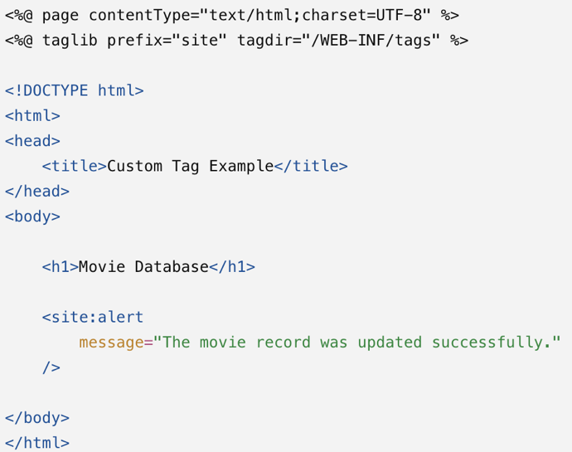
A second method is creating a Java tag-handler class. This method would be useful when I need more control than a normal tag file can provide. A basic Java tag handler can extend the SimpleTagSupport class and override the doTag() method. The doTag() method then performs the work each time the custom tag is processed.
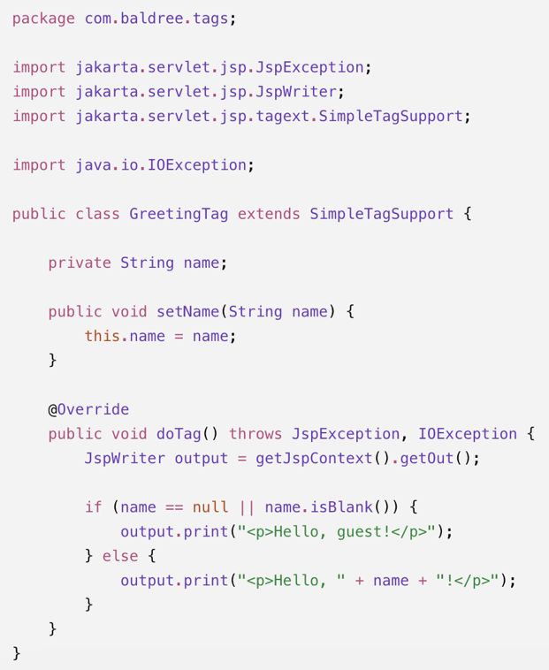
When using a Java tag handler, I would also need a Tag Library Descriptor, commonly called a TLD file. The TLD is an XML file that connects the custom tag name to the Java class. It can explain the attributes accepted by the tag, whether they are required, the type of each value, and whether the tag can contain body content. The .tld file is normally stored under WEB-INF, while the compiled Java class must be available under WEB-INF/classes or inside a JAR file under WEB-INF/lib.
Since I am using Tomcat 10.1, I would also need to use the newer jakarta package names instead of the older javax package names. Apache Tomcat explains that “the Java package used by the specification APIs has changed from javax... to jakarta...” (Apache Software Foundation, n.d.). This means that I would import jakarta.servlet.jsp.tagext.SimpleTagSupport instead of javax.servlet.jsp.tagext.SimpleTagSupport. Using the older package name could cause compilation errors even if the rest of my code was written correctly.
My opinion of custom tags is that they are helpful when I have a clear reason for creating them. I would consider using one when I notice the same JSP code appearing across several pages. They can shorten the JSP page, improve consistency, and make future updates easier. I would especially consider using custom tags for alerts, movie cards, formatted database records, headings, navigation menus, and repeated form elements.
At the same time, I would avoid creating a custom tag for every small section of a JSP page. If the code is only used one time, the custom tag may create another unnecessary file and make the project harder to navigate. I would also avoid placing complicated database processing inside a presentation tag. Custom tags are the most useful to me when they perform one clear task, have an understandable name, and remove code that would otherwise be repeated throughout the project.
After reviewing the advantages, disadvantages, and requirements, I believe custom tags can become a useful part of a JSP application. They allow repeated presentation code to be stored in one location while making the JSP pages easier to follow. I would first consider how often the code will be reused, how difficult the tag will be to maintain, and whether the operation actually belongs in the presentation layer. When custom tags are used for the correct purpose, they can help make a JSP project more organized and easier to update.

References
Apache Software Foundation. Apache Tomcat 10 Migration Guide. https://tomcat.apache.org/migration-10.html
Eclipse Foundation. Jakarta Server Pages Tag Extension API Documentation. https://jakarta.ee/specifications/pages/3.0/jakarta-server-pages-spec-3.0
Oracle. The Java EE 5 Tutorial: Custom Tags in JSP Pages. https://docs.oracle.com/javaee/5/tutorial/doc/bnalj.html
Oracle. The Java EE 5 Tutorial: Encapsulating Reusable Content Using Tag Files. https://docs.oracle.com/javaee/5/tutorial/doc/bnama.html
Oracle. The Java EE 5 Tutorial: Using Custom Tags. https://docs.oracle.com/javaee/5/tutorial/doc/bnaiy.html
Oracle. Understanding and Creating Custom JSP Tags. https://docs.oracle.com/cd/E13222_01/wls/docs90/taglib/quickstart.html

